**WEEK-2**

**Mockito Hands-On Exercises**

**Exercise 1: Mocking and Stubbing**

**Step 1:**

Created ExternalApi.java

Created MyService.java

Created MyServiceTest.java

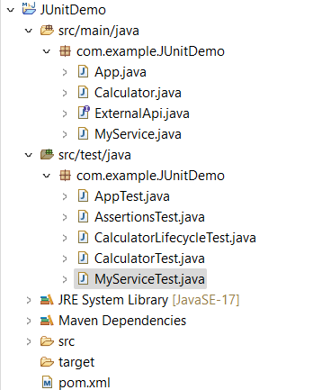

**Step 2:**

Added the Mockito Dependency to pom.xml

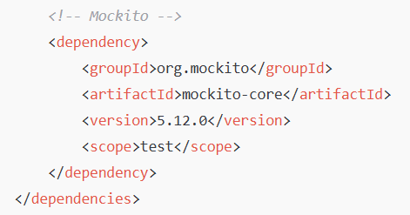

**Code:**

**Step 3:**

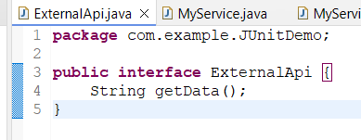

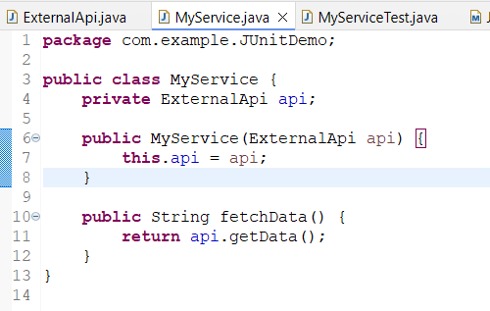

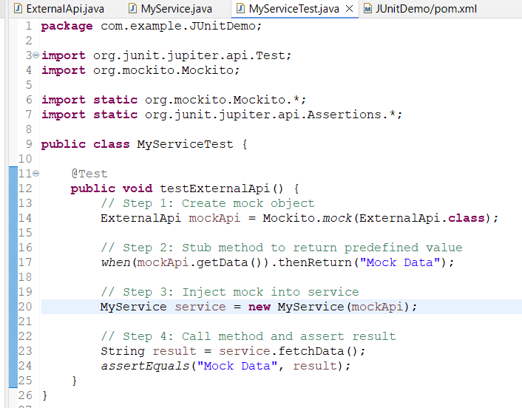

**Output:**

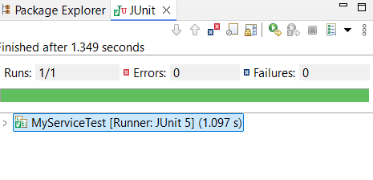

**Exercise 2: Verifying Interactions**

**Code:**

**Step 1:**

**Created the ExternalApi.java**



**Created MyService.java**



**Created MyServiceTest.java**

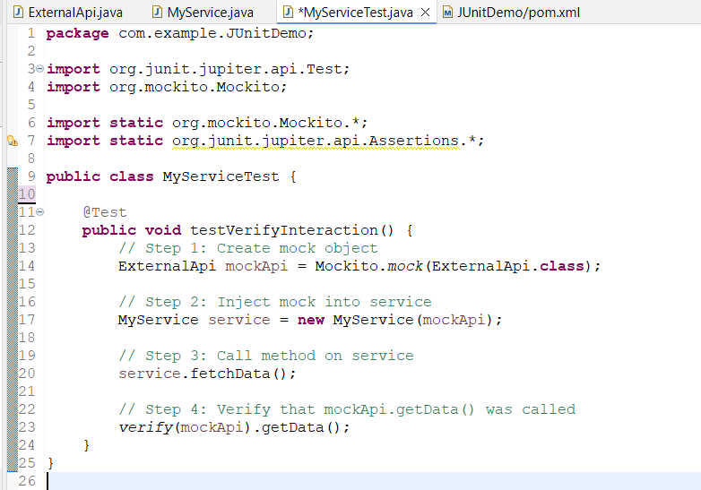

**Output:**

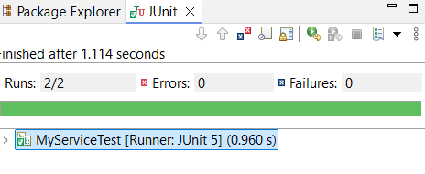

**Name: Manjeet Swaroop**

**SuperSetID: 6393474**

**EmailId:** [**manjeet.swaroop@gmail.com**](mailto:manjeet.swaroop@gmail.com)

**College: C.V RAMAN GLOBAL UNIVERSITY**